# ThinkPro Setup

* If “AppConfig.txt” file is available for location server , then keep the file on desktop and install ThinkPro,

OR

1. First time launch, Click yes to start configuration.

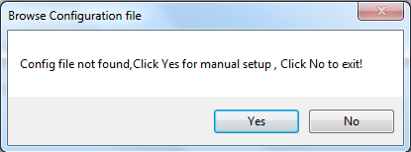

1. IF configuration file already exists then check “Connect with existing configuration file”

Or check “Create new configuration file” and click next…. Or “Create new Configuration File”

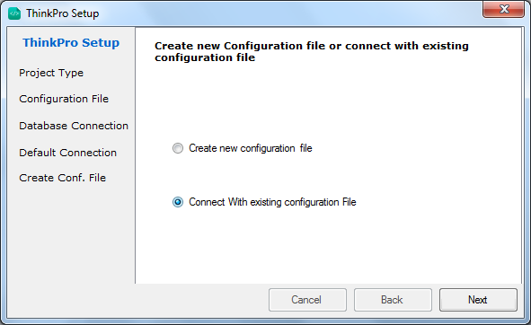

1. IF Continue with –“ Connect with existing configuration file”, Browse for the existing configuration file and click next

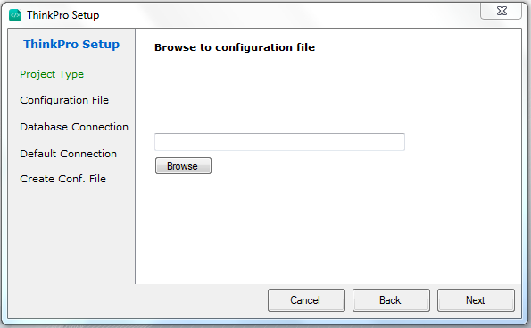

1. Database details will be fetched, Click on “Test Connection” button, if connection status is success, click on “Set Default” button.

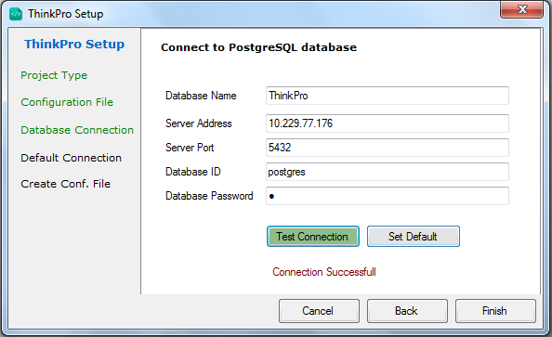

5)Click on “Set Default” to set as default connection and generate ” AppConfig.txt” file , this configuration file can be used to install this application to other system using this configuration file.

1. Create New Configuration file, Test the connection and set it as default connection and generate “AppConfig” file.



1. Click finish and restart application.